# Basic Data Transformation

## Always return in JSON format

1. Access the Product Reviews service configured in Azure API Management in the earlier hands-on – <https://pgecommerce.azure-api.net/bv/reviews/000080265628>. Note that the service returns data in XML format.
2. Since JSON is a more common data exchange format used on the web today, there is a need to transform XML to JSON.
3. Go to the policy editor for **getReviews** operation of **Product Reviews** service.

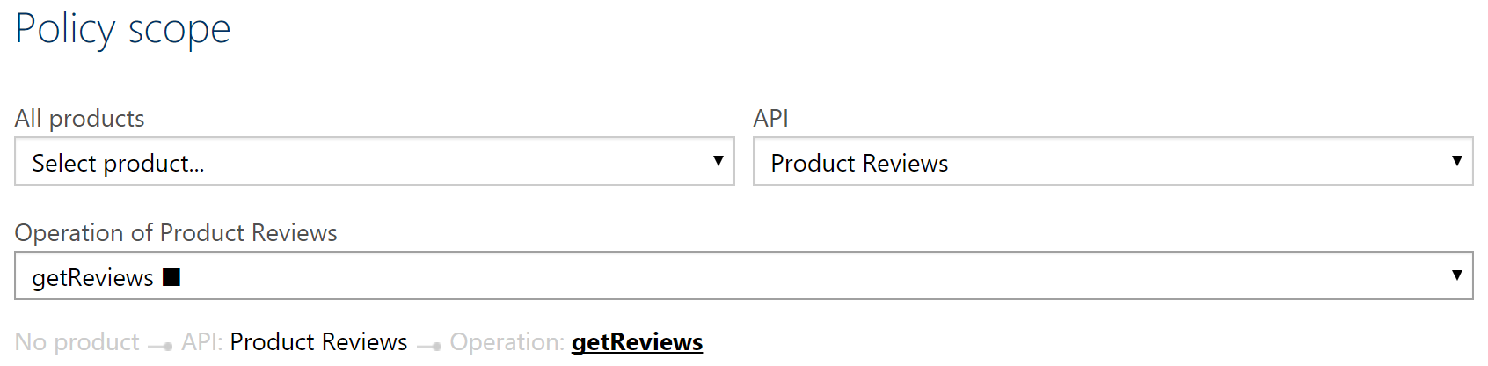

1. Add the “Convert XML to JSON” policy to the outbound section of the API, configure values as shown below and save the configuration.

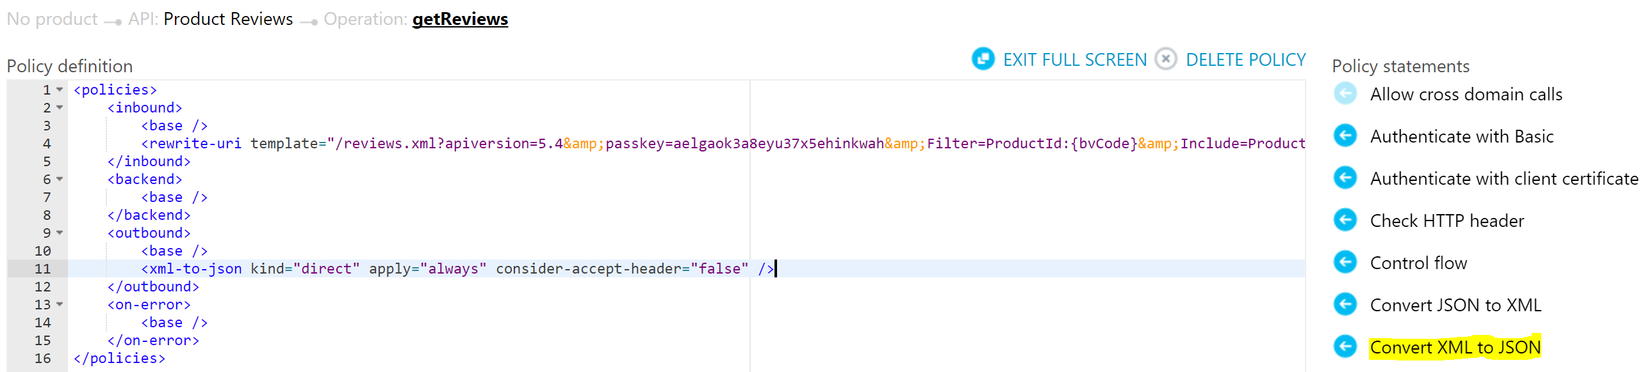

Alternatively, replace the policy definition with the content from attached file.



1. Access the Product Reviews service again and note that it returns results in JSON format now.

## return Response in requested format (OPTIONAL)

1. Modify the policy created above and change the value of **consider-accept-header** to **true**.
2. Access the Product Reviews service and note that it returns results in XML format now, as that is the default option.
3. Using a tool like Postman, access the same service and pass the following request header, as shown below.

**Accept: application/json**

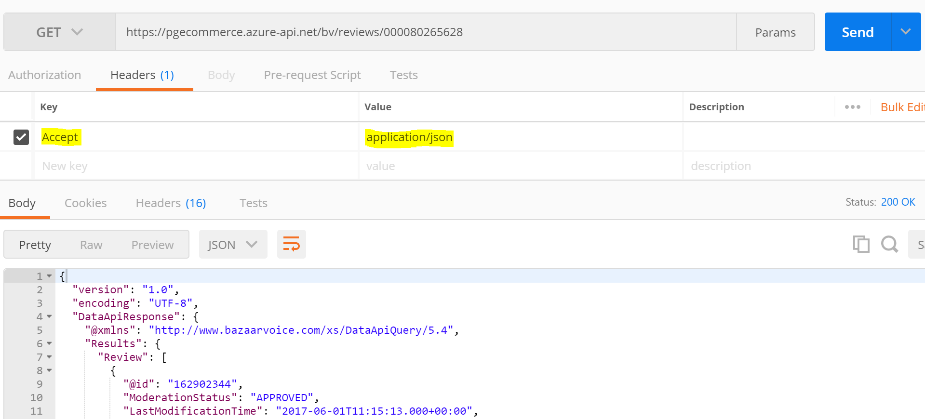

*Note: After this exercise, revert the value of* ***consider-accept-header*** *to* ***false*** *for the remaining hands-on exercises.*

# Advanced Data Transformation

1. The response of the Products Assets service includes a whole lot of details that typically is not necessary, and hence there is a need to simplify the service response.
2. Go to the policy editor for **getReviews** operation of **Product Reviews** service.
3. The “Transform XML using an XSLT” policy will be used in the outbound section of the API. Replace the existing policy code with the code from the attached file.



*Note: XSLT is a transformation language and learning that is outside the scope of this training.*

1. Access the Product Reviews service again and note that it returns results in a much simplified JSON format now.

# References

* Data transformation policies – <https://docs.microsoft.com/en-us/azure/api-management/api-management-transformation-policies>